20 Editors - Nonlinear Animation Editor
Non-Linear Animation Editor 1
Editor Areas 1
Time cursor 2
Strip types 2
Action Strips 2
Transition Strips 2
Meta Strips 2
Sound Clip Strips 2
Viewport Navigation 3
Viewport navigation 3
NLA Context Menu 3
Start Tweaking Strip Actions 3
Start Editing Stashed Actions 3
Duplicate 4
Linked Duplicate 4
Split Strips 4
Delete Strips 4
Swap Strips 4
Snap 4
Quick Favorites menu 4
How to 5

Non-Linear Animation Editor

In the NLA Editor you can use and work with so called Actions, wich contains the animation data. Instead of working with the single keyframes you work with strips made from these keyframes.

Editor Areas
The Non-Linear Animation Editor has several areas.
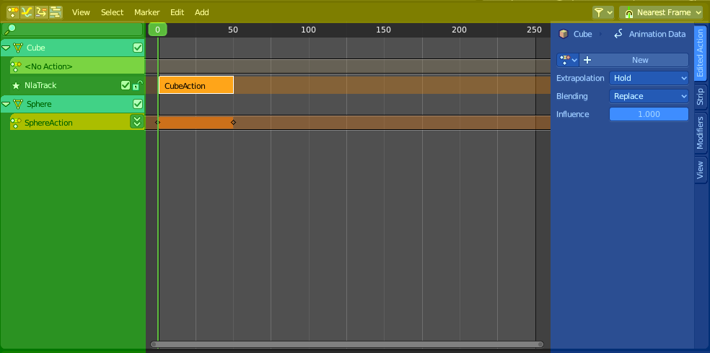
Header ( Yellow )
Channel list ( Green )
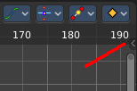
Sidebar ( Blue ). The sidebar needs to be revealed, which can be done by clicking at the small triangle button up right.
Viewport ( no color )
The header is divided into two parts. Left tools and menus. Right Options.
Menus ( Green )
Options ( Yellow )

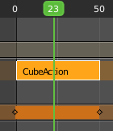
Time cursor
The Time Cursor is the green slider at the top. It is used to set and display the current time frame.

Strip types
There are three types of strips.

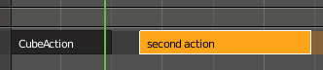
Action Strips
Action Strips contains the actual converted keyframe data.

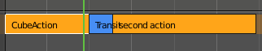
Transition Strips
Transition strips can be created by adding a transition between two Action strips. Select both action strips. In the Add menu choose Add Transition.

Meta Strips
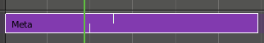
Meta Strips can be created by joining action strips together. Meta Strips still contains the Action strips that they are made of, and can be ungrouped in the add menu with remove meta.

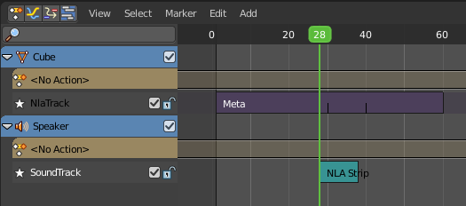
Sound Clip Strips
Controls when a speaker plays a sound clip. This strip type requires a Speaker object with a sound clip assigned. You can create a speaker object in the 3D view. The sample can be loaded in the Object Data Properties tab in the Properties editor then.

Viewport Navigation

Navigation in the viewport happens by mouse or hotkeys. Some of them does not have a menu entry. And needs to be explained here.

Viewport navigation
Clicking left at the number bar moves the frame marker.
Middle mouse button pans the view.
Holding ctrl + middle mouse button zooms the view.
Scroll Wheel zooms the view.

NLA Context Menu
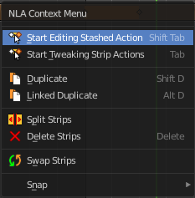
When you double right click into the viewport then you will call the NLA context menu.

Start Tweaking Strip Actions
Allows you to edit the keyframe data within the Action strip. The strip will turn grey, and in the Dope Sheet editor you will find the keyframes again, which you can tweak now.
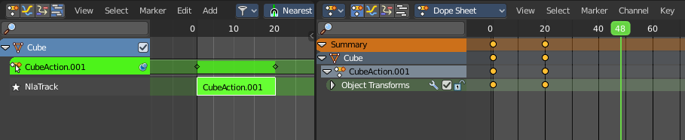

Start Editing Stashed Actions
Same as Start Tweaking Strip Actions. But with Solo already ticked. Which allows editing of the animation data for this strip only.
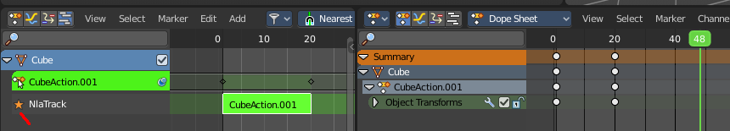

Duplicate
Duplicates the selected strip(s), and creates a new track for the duplicates. This copy is independent.

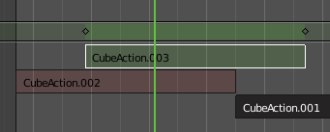
Linked Duplicate
Duplicates the selected strip(s), and creates a new track for the duplicates. This copy is linked to the original action strip. Modifications at the original will also affect the linked action strip.
Linked strips are visually different from normal strips. And when you start to modify the linked duplicate, then the original strip will turn red.

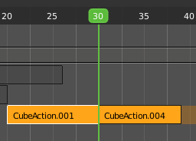
Split Strips
Splits the selected strip(s) at the marker position.

Delete Strips
Deletes the selected strips

Swap Strips
Swaps the selected strips.

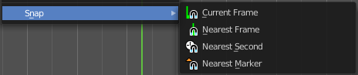
Snap
Snaps the selected strips by the chosen method.

Quick Favorites menu


When you right click at a menu or a button, then a right click menu will open. Tools have usually a Add to Quick Favorites menu entry.

The Quick Menu is empty by default. With Add to Quick favorites you can add this menu to the Quick menu.

In the 3D view we have a menu called Quick in the header, which shows this content then. In the Dope Sheet Editor you can just call it with its hotkey. Q. It has no regular menu entry here.

How to

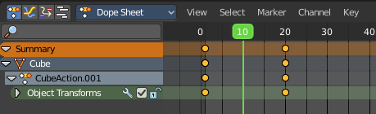
First create a keyframe animation.

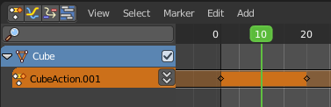
Switch to NLA editor.

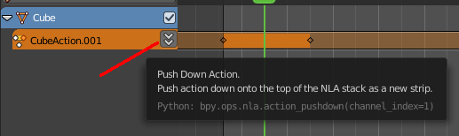
Click at the Push Down Action button to create the Action strip for this keyframe animation.

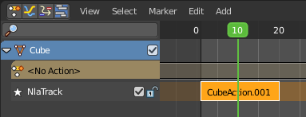
This turns your keyframe sequence into a single Action strip, which can now be used in the NLA editor.

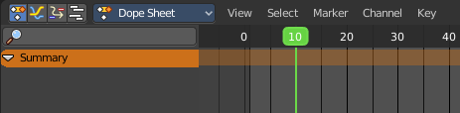
You will notice that the keyframes in the Dope Sheet editor are gone. They are now part of the Action strip.

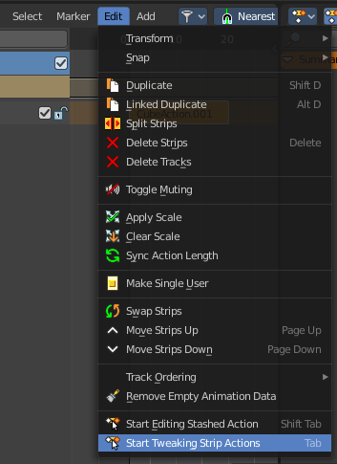
When you want to edit the keyframes of an Action strip then you need to enter the tweak mode by activating Start Tweaking Strip Actions.

This turns the strip to green to tell you that you are now in tweak mode. And it reveals the keyframes, which you can now edit in Dope Sheet editor.

To leave the edit mode click the menu item again, or press Tab key.

